**Homework 05**

Deadline[1]: Wednesday September 23

Student: Austin Gailey

Consider the grammar below specified using EBNF notation.

|  |
| --- |
| bool_exp = bool_exp ( ´and´ | ´or´ ) bool_exp bool_exp = factor ( ´>´ | ´>=´ | ´=´ | ´<=´ | ´<´ ) factor factor = ´identifier´ | ´literal´ |

This grammar can be converted to the format accepted by the [SLR table generator tool](http://jsmachines.sourceforge.net/machines/slr.html) discussed in class, as seen below. Make sure you understand that the two grammars are essentially the same. Substitutions made: bool_exp = B, factor = F, identifier = i, literal = l.

|  |
| --- |
| 0. S -> B  1. B -> B and B  2. B -> B or B  3. B -> F > F  4. B -> F >= F  5. B -> F = F  6. B -> F <= F  7. B -> F < F  8. F -> i  9. F -> l |

The table (on the next page) shows the SLR table built from the grammar using the online tool. Note that for this particular grammar the tool gives more than one option for some actions.

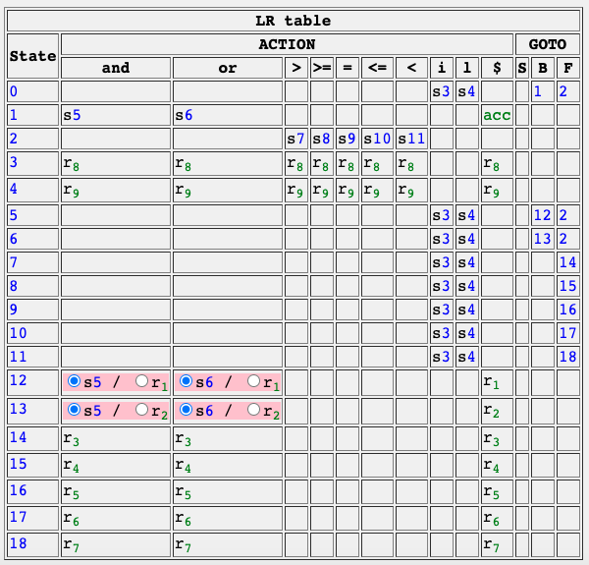

Using the grammar’s productions and the SLR table above, complete the table below describing the steps taken by an SLR parser, including the contents of the stack and the input, while evaluating a boolean expression. First steps were given to you.

|  |  |  |
| --- | --- | --- |
| **Stack** | **Input** | **Action** |
| 0 | i > 1 and 1 = 1 $ | s3 |
| 0 i 3 | > 1 and 1 = 1 $ | r8 |
| 0 F | > 1 and 1 = 1 $ | 2 |
| 0 F 2 | > 1 and 1 = 1 $ | s7 |
| 0 F 2 > 7 | 1 and 1 = 1 $ | s4 |
| 0 F 2 > 7 1 4 | and 1 = 1 $ | r9 |
| 0 F 2 > 7 F | and 1 = 1 $ | 14 |
| 0 F 2 > 7 F 14 | and 1 = 1 $ | r3 |
| 0 B | and 1 = 1 $ | 1 |
| 0 B 1 | and 1 = 1 $ | s5 |
| 0 B 1 and 5 | 1 = 1 $ | s4 |
| 0 B 1 and 5 1 4 | = 1 $ | r9 |
| 0 B 1 and 5 F | = 1 $ | 2 |
| 0 B 1 and 5 F 2 | = 1 $ | s9 |
| 0 B 1 and 5 F 2 = 9 | 1 $ | s4 |
| 0 B 1 and 5 F 2 = 9 1 4 | $ | r9 |
| 0 B 1 and 5 F 2 = 9 F | $ | 16 |
| 0 B 1 and 5 F 2 = 9 F 16 | $ | r5 |
| 0 B 1 and 5 B | $ | 12 |
| 0 B 1 and 5 B 12 | $ | r1 |
| 0 B | $ | 1 |
| 0 B 1 | $ | acc |

1. Homework is due right before class.